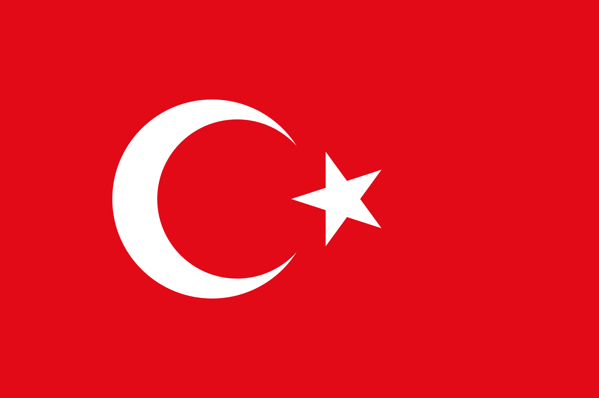
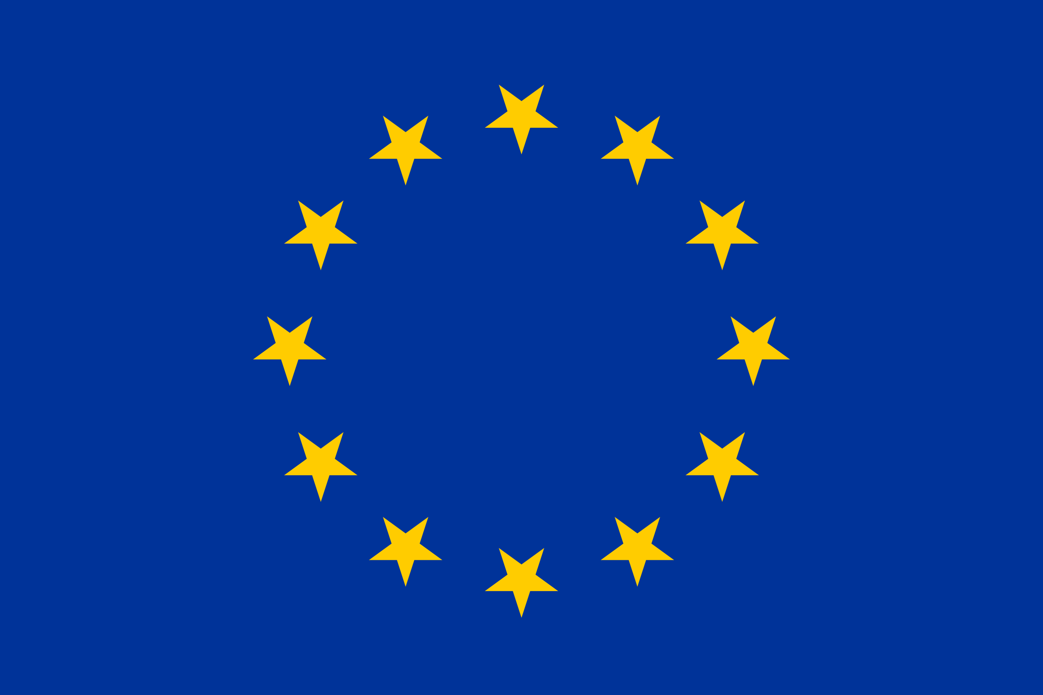
EU-Turkey High Level Economic Dialogue
Joint Press Release
December 8, 2017, Brussels
The second High-level Economic Dialogue (HLED) between the EU and Turkey was held in Brussels on 8 December 2017. The HLED is intended to support high level meetings that began on 29 November 2015 between the two sides and the political dialogue meetings, as a useful platform also in view of the accession process. The HLED aims to contribute to the further enhancement of economic relations and creates a business platform to bring business circles together.
European Commission Vice-President Jyrki Katainen and Turkey's Deputy Prime Minister Mehmet Şimşek co-chaired the HLED. The EU delegation included Commissioner Pierre Moscovici (Economic and Financial Affairs, Taxation and Customs) and Commissioner Malmström (Trade). The Turkish delegation included Minister Nihat Zeybekci (Economy) and Minister Bülent Tüfenkci (Customs and Trade).
The HLED consisted of the EU-Turkey Business Dialogue in the morning of 8 December 2017, when Ministers of the Government of Turkey in charge of economic policy-making and their counterparts from the European Commission gathered with major Turkish and European business community representatives and International Financial Institutions to discuss mutual economic relations.
The second part of the HLED was held in the afternoon when government-to-government discussions were held about the current situation and outlook for the EU and Turkish economies against the background of the global economic developments and risks. Ministers and Commissioners noted that global economic growth continues to recover and that current growth prospects are encouraging. Risks to the global economy have become more balanced this year but downside risks remain sizable. The most prominent are renewed volatility in financial markets, increase in protectionism and geopolitical tensions.
Participants addressed structural challenges to growth and competitiveness in their respective economies and policies to meet them. Ministers and Commissioners emphasized the importance of structural reforms to achieve strong, sustainable, balanced and inclusive growth. The discussions put special emphasis on investment and business environment issues of mutual interest, taking stock of the EIB's, the EBRD's and the CEB´s activities in Turkey and in the EU.
Ministers and Commissioners underlined the importance of economic relations between the EU and Turkey. Vice-President Katainen, responsible for jobs, growth, investment and competitiveness, pointed out: "We conducted a frank and amicable consultation today, during which I stressed the importance of upholding individual rights and the rule of law for the benefit of investment and economic growth. We look forward to continue our financial and economic engagement with Turkey".
Turkish Deputy PM Şimşek, responsible for Economic and Financial Affairs, drew attention to Turkey’s dedication to democracy and rule of law for the benefit of both its citizens, and peace and safety of the region. In a similar vein, DPM Şimşek underlined that HLED does not constitute an alternative to the accession process and stated that “Turkey remains anchored to full EU membership, which serves to the best interest of both parties. We look forward to smooth and swift upgrading of the Customs Union.” DPM Şimşek also stressed the importance of communication and cooperation between Turkey and EU due to strong economic and political ties.
Building on this fruitful exchange of views, both parties welcomed the intention to meet again in the same format next year in Turkey.

EIB: European Investment Bank; EBRD: European Bank for Reconstruction and Development; CEB: Council of Europe Development Bank

